# **CROPMON**

|  |  |
| --- | --- |
| Student Name | **Tadhg Ó Conghaile** |
| Student ID | **20091418** |

This project is a sensor to monitor moisture in a plant. I will switch on an alert from my phone, then once the sensor detects that the soil is dry, I will get a notification sent to my phone, at which point I can water the plant and set the alert again.

# **Tools, Technologies and Equipment**

## **Hardware**

A Raspberry Pi powered by socket. This device will take Soil Moisture readings from a sensor and via GPIO. The Raspberry Pi will transfer data via WiFi using the built-in adapter.

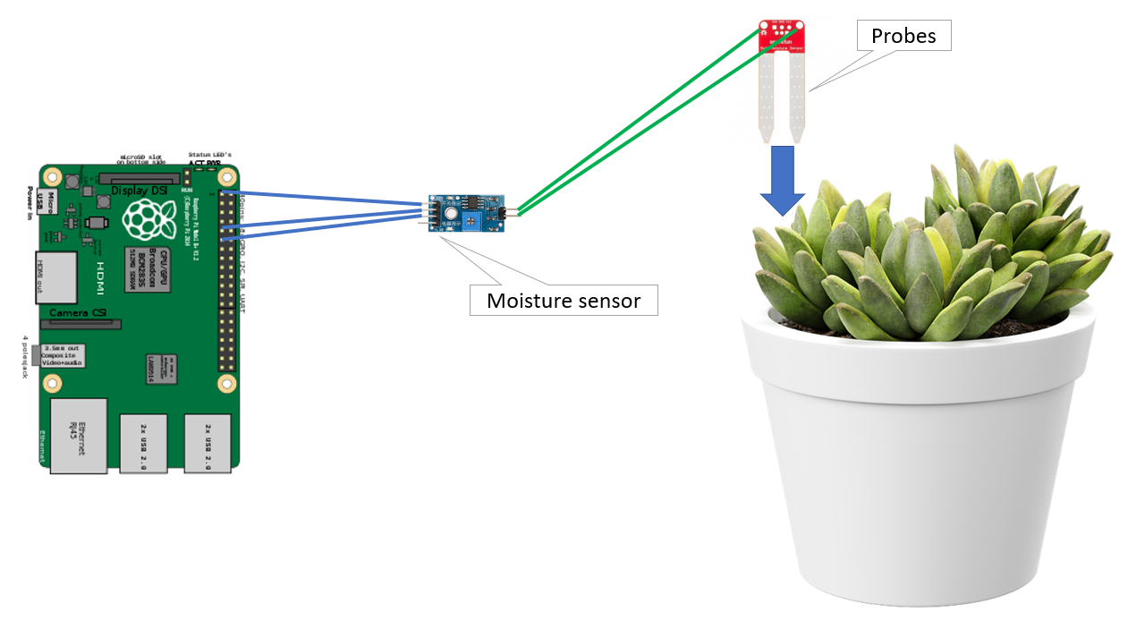

## **Data & Communication**

A Python Script will run on the raspberry Pi and interact with the sensor via GPIO. This script will send MQTT messages using PubNub. A NodeJS application hosted in Azure will consume these messages and then send a web request to IFTT

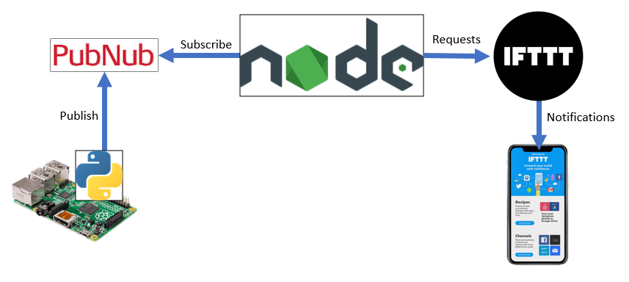

# **Project Repository**

https://github.com/Tadhg-io/cropmon